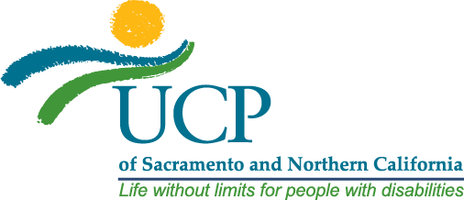
FOR IMMEDIATE RELEASE Contact: Steve Horton
December 18, 2019 shorton@ucpsacto.org | 916-283-8312

Ability Central Funds Nonprofit Leadership Development at UCP

SACRAMENTO, CA – UCP of Sacramento and Northern California is honored to announce that Ability Central has awarded $37,200 in funding to create a Leadership Development Program and ensure organizational sustainability. Investing in employee development and retention will help UCP improve the quality of services provided to children and adults with developmental disabilities and their families.

With limited resources compared to the for-profit sector, the non-profit industry faces many challenges retaining talented employees. UCP hopes to overcome these challenges by providing additional opportunities for employees to grow their leadership skills.

“Using a combination of mentorship, online and formal education, UCP’s new Leadership Development Program will prepare the next generation of supervisors, managers, and leaders to step into these roles. We are grateful to Ability Central for this opportunity to create a program that will benefit our clients, employees, and the rest of the disability service provider industry,” says Doug Bergman, President and CEO of UCP of Sacramento and Northern California.

The grant funding from Ability Central was awarded through a pilot grant program to invest in non-profit capacity building. Ability Central, formerly known as the Disability Communications Fund (DCF), has been making grants and collaborating with community leaders to improve communication and information access for people with disabilities since 2010.

For more information about UCP of Sacramento and Northern California, please visit http://www.ucpsacto.org.

###

About UCP
UCP was started in Sacramento in 1955 by a group of concerned parents who believed children with development disabilities deserved to be included in home and community life rather than state institutional care. Over sixty years later, UCP now serves children and adults with over 20 types of developmental disabilities, 51% have autism, 34% intellectual disability, 9% cerebral palsy and 6 % Down syndrome & epilepsy. UCP’s Six Programs serve 6,004 clients across eight counties.

